How could post-postmodernism look like?
Capturing the beauty of postmodernism, adding thinking frameworks for a better world society
How this topic attracted my personal attention and fuelled my energy:
In a way, we as students and teachers of SoT are thinkers in our era, and this era is deeply rooted in postmodernism. At some point in time during the SoT curriculum, I was quite frustrated of the over-relativism in thinking models and discussions.
History – Definitions (wiki)
Postmodernism is a broad movement that developed in the mid- to late 20th century across philosophy, the arts, architecture, and criticism, marking a departure from modernism.
Postmodernism is generally defined by an attitude of skepticism, irony, or rejection toward what it describes as the grand narratives and ideologies associated with modernism, often criticizing Enlightenment rationality. Postmodern thinkers frequently describe knowledge claims and value systems as contingent or socially-conditioned, framing them as products of political, historical, or cultural discourses and hierarchies.
A worldview is the fundamental cognitive orientation of an individual or society encompassing the whole of the individual's or society's knowledge and point-of-view. The intellectual movement of postmodernism uses the concept of worldview.
Worldviews and postmodernism are to be praised for liberating our minds to a large extent from suffocating doctrines, building capacity for self-exploring and expanding intelligence of individuals and societies. This explains the success of these thinking frameworks from their origins in the 1950’s till today.
Main Criticism on postmodernism (Wiki):
Main criticism shares the opinion that it lacks coherence and is hostile to the notion of absolutes, such as truth. Specifically it is held that postmodernism can be meaningless, promotes obscurantism and emphasizes relativism (in culture, morality, knowledge) to an extent that is epistemically and ethically crippling. (e.g. postmodernism uses relativism to the extent that it cripples most judgement calls)
Worldviews and postmodernism are an invitation to think freely and more individually, but typical biases appear in this process (see youtube: Shepherd, M., March 2018, “3 kind of bias that shape your worldview”):
- Confirmation bias: finding evidence that confirms own belief
- Dunning-Kruger effect: overestimating own’s ability
- Cognitive dissonance: person’s belief clashing with new information

One of the definitions of post-postmodernism (in wiki):
Post-postmodernism is a wide-ranging set of developments in critical theory, philosophy, architecture, art, literature, and culture which are emerging from and reacting to postmodernism. Another similar recent term is metamodernism.
Post-Postmodernism: how could it look like?
As an evolution starting from postmodernism, not a revolution, capturing its beauty and value
  - Keep most of the postmodern insights
  - Go back to its origins, how postmodernism was meant to be:
    - E.g. Leo Apostel (1994), a worldview contains an epistemology of “what is true and false” (Wiki)
    - E.g. During a conference Bruno Latour was asked to answer a question ..and the psychologist hesitated before asking him: “Do you believe in reality?” Latour first thought it was a joke..
Improving / adding:
- Metamodernism (Wiki) is a proposed set of developments in philosophy, aesthetics, and culture which emerge from and react to postmodernism. One definition characterizes metamodernism as mediations between aspects of both modernism and postmodernism. Another similar term is post-postmodernism.
  - oscillates between modernism and postmodernism like "a pendulum swinging between…innumerable poles"
  - Metamodernism: Plato's metaxy, which denotes a movement between opposite poles as well as beyond them
  - "grand narratives are as necessary as they are problematic, hope is not simply something to distrust, love not necessarily something to be ridiculed."
  - "go forth and oscillate!"
- Deal with a number of Taboos:
  - Taboo of ranking thinking models for a certain problem in its context
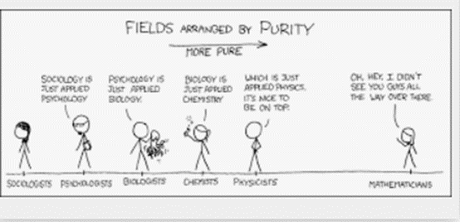
    - Prof. Johan Braeckman (UGent): “where science is strong, philosophy should retreat .. and vice versa”
    - Not underestimating power & importance of law of physics:
      - second law of thermodynamics,
      - evolution theory, etc.
      - During a meeting with post-modernists, the physicist Alan Sokal, who was getting feedback from them that “the laws of physics are mere social conventions,” invited them to jump out the window of his 21st-floor apartment.
  - Taboo of “power & authority”
    - Authority has a double meaning, today is an out-of-fashion word:
      - the power or right to give orders, make decisions, and enforce obedience => not the way to go in post-postmodernism
      - the power to influence others, especially because of one's recognized knowledge about something (e.g. a genuine influencer). => useful to guide post-postmodernism
    - Philosophy and power/influence: good balance today?
  - Seeking for “truer truth” and acting upon truth
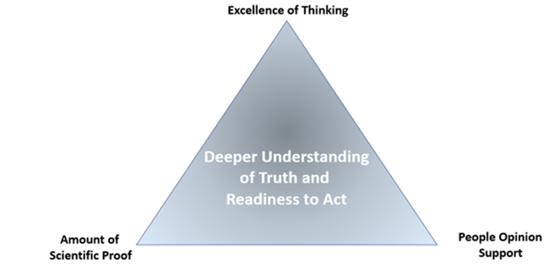
>> Measuring level of truth and adjusting one’s worldview

